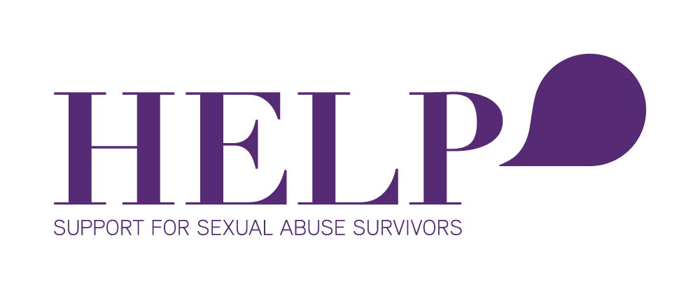

Sexual Violence Crisis Support Counsellor Positions

HELP’s 24-hour crisis service provides counselling, information, and support to women, children, and families who have experienced sexual violence either recently or in the past. The service includes supporting clients through police procedures and medical processes.

Our Crisis Team is currently looking for qualified psychotherapists, psychologists or counselors, preferably with at least 12 months post-qualifying experience, to join our all women team. We have part time positions available in both our After Hours and Day teams. Additional training and/or experience in sexual trauma recovery is a definite advantage, however, induction and training will be provided.

This role involves working with Police, MEDSAC Doctors, phone counselling and support, referral intake and face-to-face crisis sessions.

Relevant experience / skills required:
- Working with survivors of trauma and/or sexual violence and knowledge of crisis intervention strategies
- Have an understanding of the impact & effects of sexual violence
- Articulate thinking around feminist philosophy
- Demonstrate commitment to Te Tiriti O Waitangi.
- Have an understanding and appreciation of teamwork and team dynamics
- Have excellent communication and Administration skills
- Well skilled in keeping client records and proficient at using and understanding online database systems, including data entry and reporting
- Tertiary qualification in Counselling or Psychotherapy
- Registered with a relevant professional governing body

If you’re interested in joining our After Hours or Day Team, Please email your CV to recruitment@helpauckland.org.nz
by 9th August 2019

