**Registration Form**

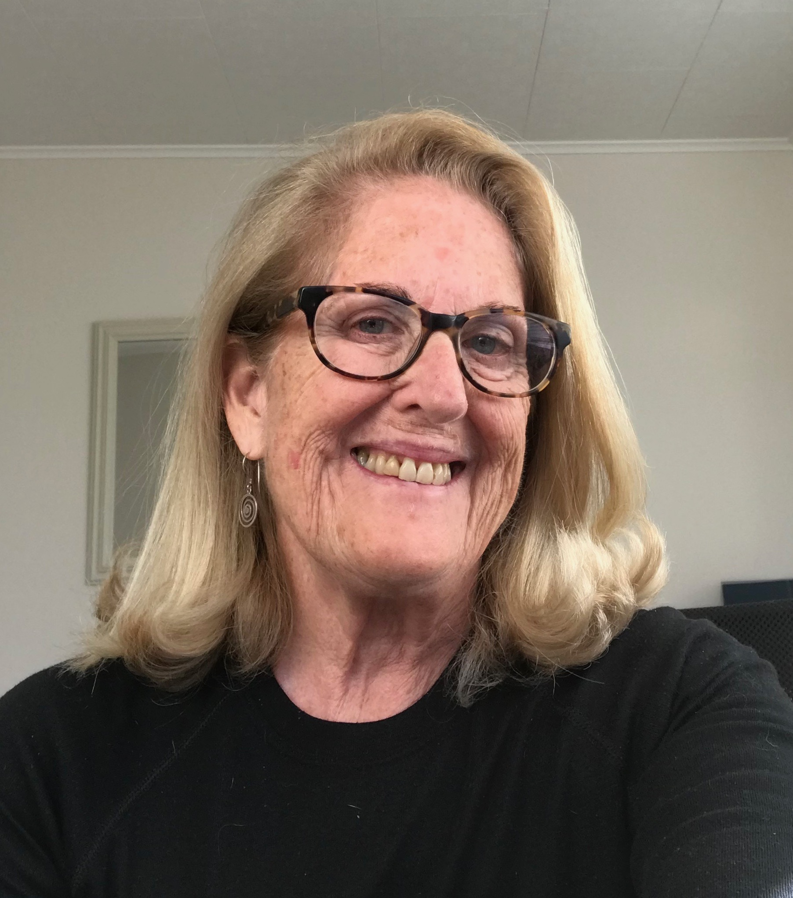

As Director of QPR and a Master QPR Trainer since 2008, Louisa brings a wealth of knowledge and experience to the trainings she presents.

Louisa received her Doctorate in Psychology from the University of Idaho with a research emphasis on both cross-cultural and biological psychology.

She has 20 years of clinical experience working extensively with GPs and specialists to build innovative treatment models to integrate psychological services into general practice medicine.

Louisa has been a consultant to the Hawkes Bay DHB Acute Mental Health Service, and the Clinical Manager for a Ministry of Health-funded suicide bereavement service. Louisa has also provided consultation services to the Coroner’s office reviewing suspected suicide deaths.

Louisa currently consults with a wide variety of organisations regarding suicide prevention, and delivers QPR trainings throughout New Zealand for Government Organisations, NGOs, PHOs, GPs and other health professional groups.



QPR New Zealand

**Advanced Suicide Risk Management**

**and Triage Training**

Presented by Louisa Walker, PhD

**When:** **Tuesday 3 March 2020**

**Time:** **8.30am – 4.30pm**

(Morning tea, lunch, afternoon tea included)

**Venue:** **St Columba Centre**

40 Vermont Street

Ponsonby

Auckland

**Parking:** Free all-day parking available

**Course investment: $320 incl. GST**

Includes course workbook and other resources

RSVP

**Yes, I would like to attend the QPR Advanced Suicide**

**Prevention Training:**

**Your name:**

**Organisation:**

**Role/Profession:**

**Email:**

**Work DDI:**  **Mobile:**

Please let us know any dietary requirements and we will do our best to accommodate:

***Please provide contact details of where we should send the invoice to (yourself, Manager, Accounts etc):***

Their Email:

Their DDI:

**Please email your registration form to Grant Walker:**

[**grant.walker@qpr.org.nz**](mailto:grant.walker@qpr.org.nz)