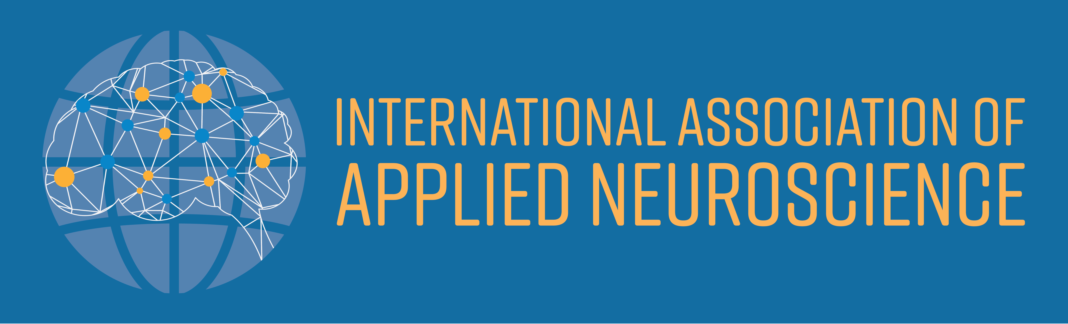

2nd Annual IAAN Conference of Applied Neuroscience
Thursday 21 May – Saturday 23 May 2020
Rydges on Swanston, 701 Swanston Street, Carlton
& The Melbourne Brain Centre

- Up to 20 additional speakers, covering a wide range of applied neuroscience topics | - Peer-to-peer networking and forum  - IAAN Annual General Meeting
- 3 conference streams (Psychotherapy,  Organisational and Educational)  - Keynotes, oral presentations and workshops | - 24 Continuing Professional Development Points  - FREE IAAN MEMBERSHIP for full-time students
Conference Keynote Speakers
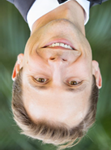
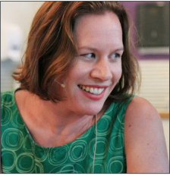
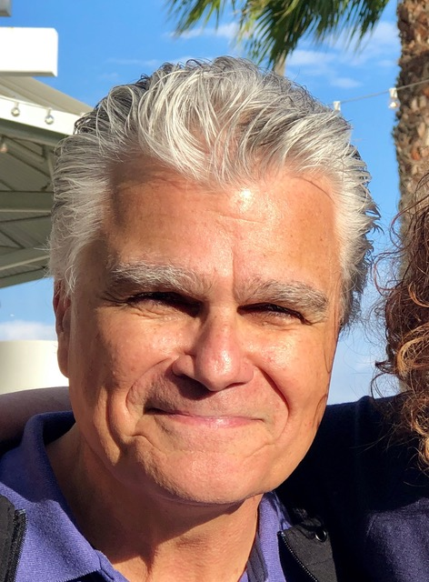

Dr Louis Cozolino Dr Amee Baird Dr Jared Cooney Horvath
Psychologist, Author Neuroscientist, Author Educator, Neuroscientist
Los Angeles, USA Newcastle, Australia Melbourne, Australia

Dr Louis Cozolino
- Pre-Conference Full Day Workshop – 20 May 2020 – Rydges Hotel
- Public Lecture – 21 May 6.15pm – Melbourne Brain Centre
Dr Cozolino holds degrees in philosophy, theology, and clinical psychology. His interests are in the areas of the synthesis of neuroscience with psychotherapy, education, management and leadership. He is the author of seven books The Neuroscience of Psychotherapy, The Social Neuroscience of Education, The Neuroscience of Human Relationships, The Healthy Aging Brain, Attachment-Based Teaching, The Making of a Therapist, and Why Therapy Works. He has also authored, co-authored articles and book chapters on child abuse, schizophrenia, education, language and cognition. Dr Cozolino lectures around the world on brain development, evolution, psychotherapy and maintains a clinical consulting practice in Los Angeles.
Please register online at www.iaan.com.au/events/
PO Box 4445 Qld 4078 conference@iaan.com.au +61 (0) 491 073 689

