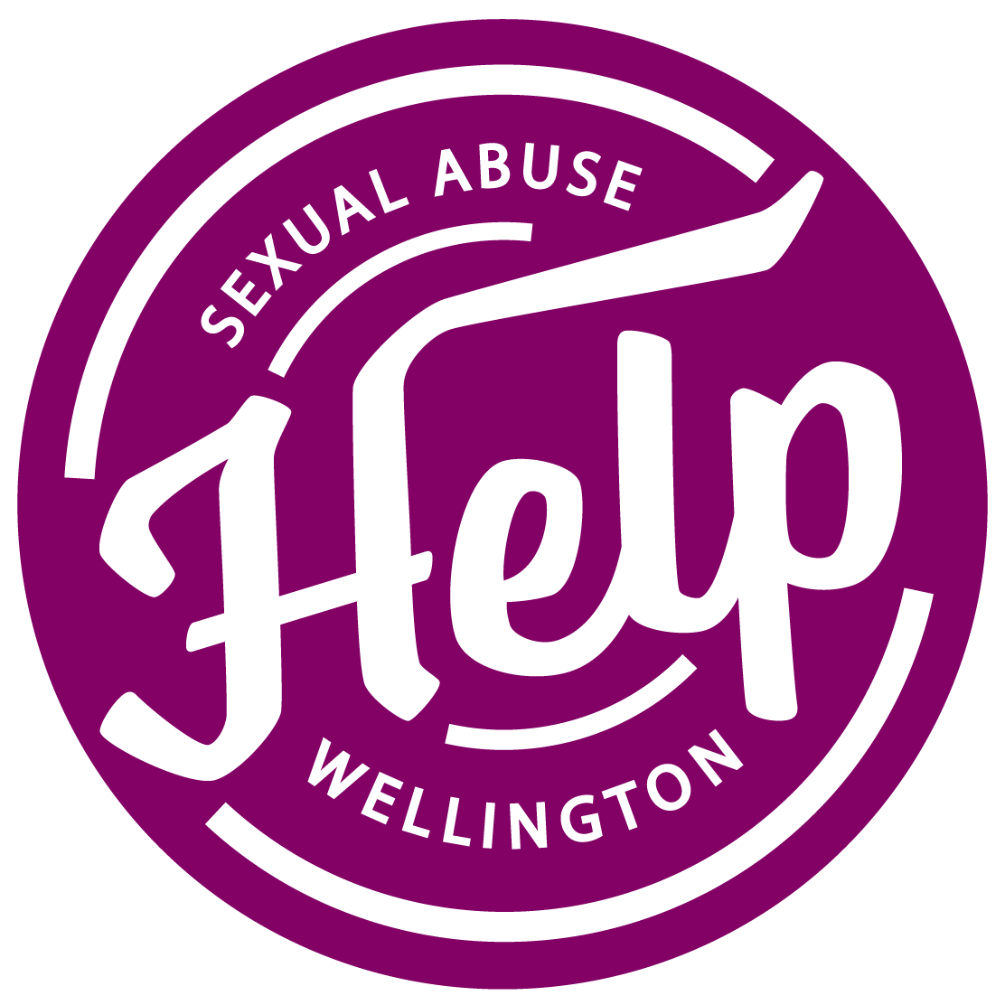
Wellington HELP is seeking new contract therapists
The Wellington Sexual Abuse HELP Foundation provides specialist support to survivors of sexual abuse, their families and whānau across the Wellington region. We have been operating since 1985 and provide a wrap-around service for survivors and their whānau, including crisis, social work and therapeutic support.
We are a registered ACC ISSC Supplier.

Seeking new therapists
We are currently seeking expressions of interest from contract therapists to provide specialist counselling to our clients under the ACC ISSC programme.
If you have:
- Extensive counselling experience
- Experience in working with people affected by sexual abuse and sexual assault
- Confidence in using IT and some skills/experience with client database systems
- Indemnity insurance
HELP can offer:
- Support with ACC provider registration
- Computer and client database support
- A friendly working environment
- Support with administration of ACC invoicing
For more information, please contact:
Conor Twyford, Chief Executive
conor@wellingtonhelp.org.nz

